GEOL 551: Applied Petroleum Geology   
Assignment #2 - Due 2/11/2019

Nadima Dwihusna

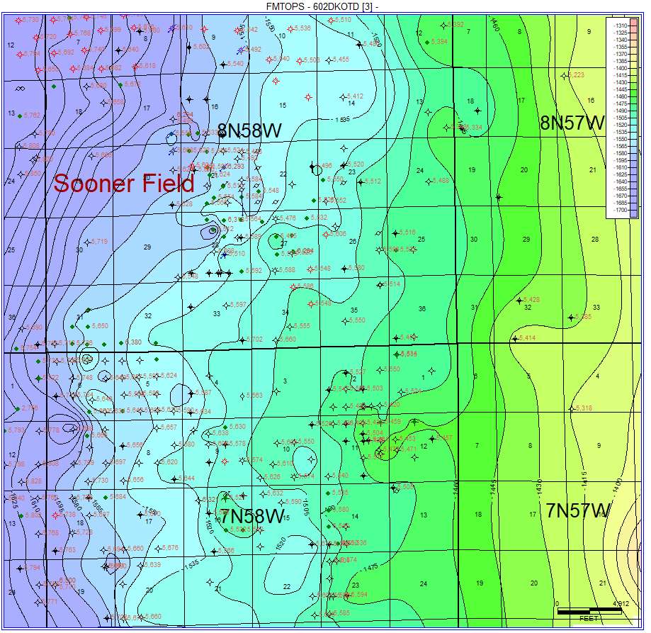

Figure 1: *(Before)* Original grid map with 602 Dakota D3 Sand formation tops contour intervals. There are several geologically inaccurate (circular/nose-like) features.

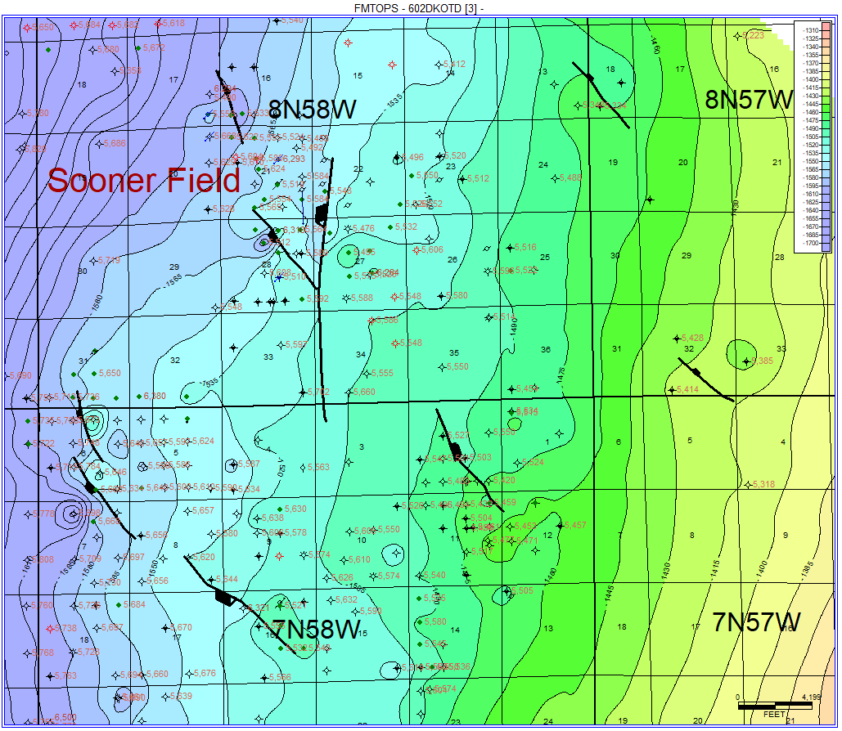

Figure 2: *(After)* Final grid map from Figure 1 with added normal faults and several modified

contour intervals to look more geologically correct.

In this assignment, the map grid was recreated and modified for the Formation Tops 602 Dakota D3 Sandstone shown from Figure 1 (*before*) versus Figure 2 (*after*). The Figure 3 below shows several of the corrected drawn contour interval and normal fault lines. When re-creating the grid, the “Highly Connected Features (Least Squared)” method was used, the limits were set to “Screen Limits,” and the “use overlay contour lines,” “include Control Points,” and “include faults” settings were chosen.

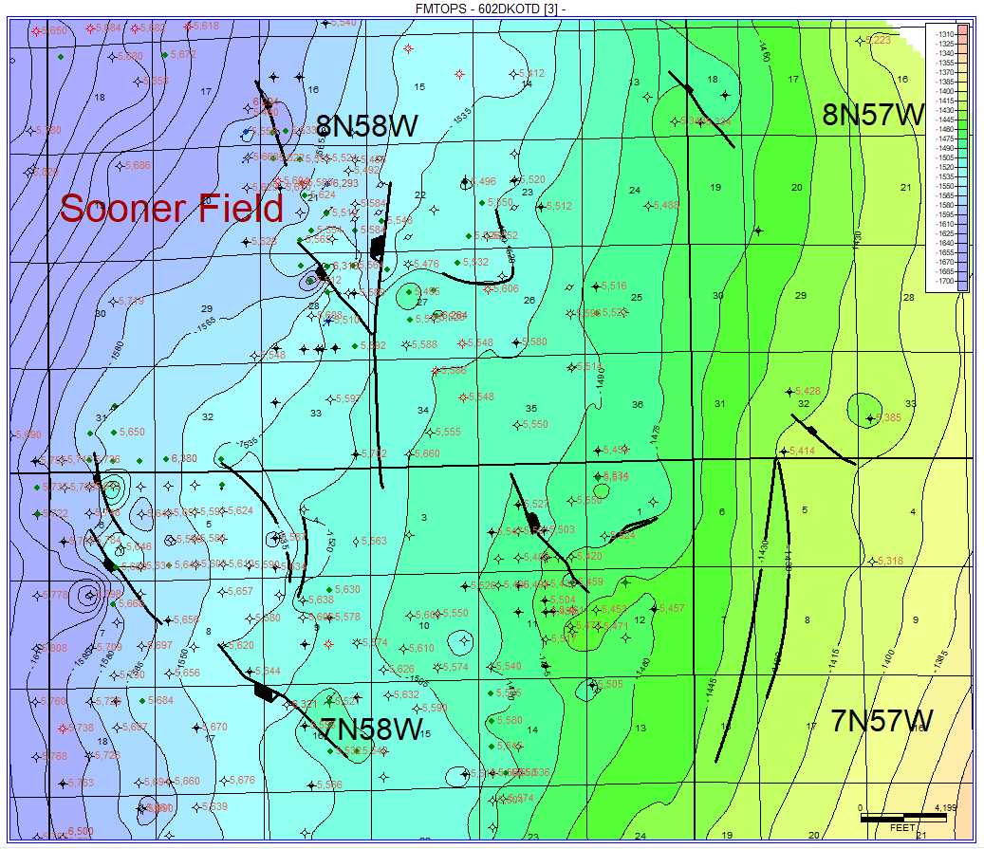

Figure 3: Map of all added faults and corrected contour interval lines.